**Total chl *a***

**No homogeneity of variances**

**Sig differences btwn treatments**

**One way: DIN = DIN + LP = DIN + HP > HP = LP**

**RCB: DIN + HP – DIN + LP ≥ DIN > LP = HP**

**Cyanobacteria**

**Issues with normality test**

**One way = homogeneity of variances, no difference between treatments**

**Two way = no homogeneity of variances, no difference between treatments but differences between bioassays**

**Green Algae**

**Cryptophytes**

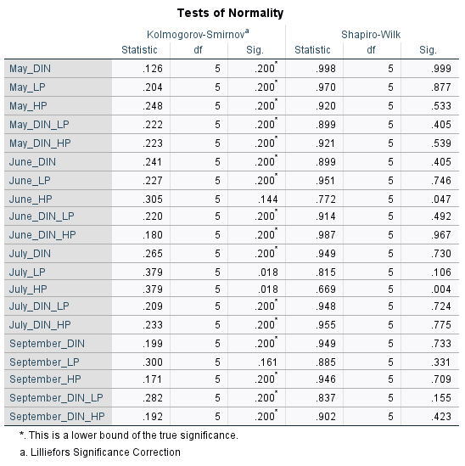

**Diatoms**

**Dinoflagellates**

**Haptophytes**

